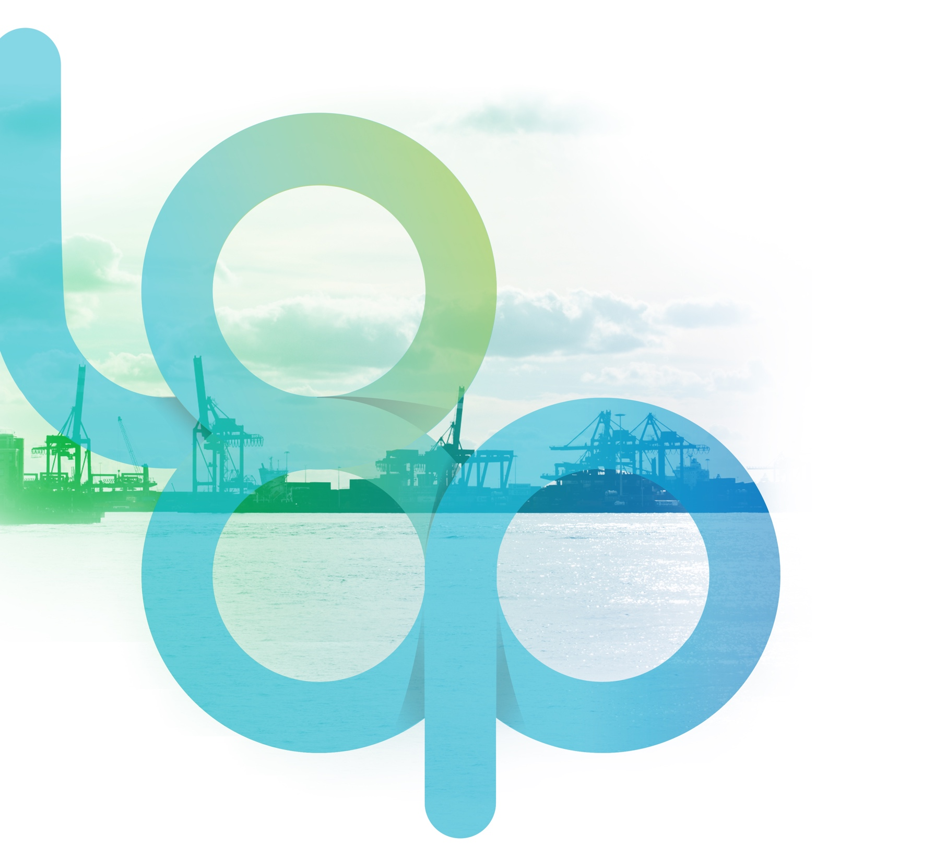
circular economy network of ports (loop-ports)
Mapping of EU ports
Lead:
Universidad Politécnica de Madrid (Spain)
Álvaro Campos Duque
Rafael Molina Sánchez

Contributors:
Fundación Valenciaport (Spain)
Universitat de València (Spain)
NTU International (Denmark)

Reviewed by:
Universidad Politécnica de Madrid (Spain)
Fundación Valenciaport (Spain)
Approved and Edited by:
Fundación Valenciaport (Spain)
Jorge Miguel Lara López
Rocío García Molina

Contents
Contents 3
Executive Summary 4
Selection of Ports 5
Analysis of the Database: Type of traffics 6
Analysis of the Database: Statistical Results 7
Analysis of the Database: Other results 8
Port Sustainability Indicators 9
Conclusions 11
References 13

Executive Summary
The present report resumes the objectives, methodology and results of Task 1.1 – Mapping of ports of the project Circular Economy Network of Ports (LOOP-Ports), funded by EIT SGA 2018, as part of Work Package 1: Mapping of Current Ports Status in Relation to Circular Economy.
This task was mainly focused on the development and analysis of a database including most relevant ports from the European Union (EU) regarding Circular Economy (CE), together with a set of variables for their characterization. The main objective of this task, as a first step in the project, was to select ports and variables of relevance, to analyze this information and to publish the results in the project’s webpage.
A total of 480 ports were included in the database, considering all Core and Comprehensive ports from the Trans-European Transport (TEN-T), other ports of relevance with more than 1 million passengers per year or handling more than 1 million GT (Gross Tonnage) and ports with more than 100 fishing vessels registered. A total of 45 variables (grouped into 7 main subject areas) were selected and characterized for each port. After accomplishing a quality check of the full database, the results were uploaded in the project’s webpage (https://www.loop-ports.eu/), where they can be interactively consulted.
This report provides a summary of the analysis carried out at the beginning of the project in order to provide a broad picture of European ports, trying to connect the information of the database to port’s suitability to implement CE initiatives.

Selection of Ports
At the beginning of the project a total of 480 ports across the European Union were selected and analyzed, including the typologies detailed below.
All ports considered by the European Commission as Core and Comprehensive were included in the database (105 and 223 ports respectively). These ports, as part of the TEN-T network, are the hubs for main goods and passengers traffics inside and outside Europe. Therefore, they are strategic areas for studying and addressing CE initiatives. In addition, as they are nodes for the transfer of cargo, they also represent real industrial districts where value-added activities are generated.
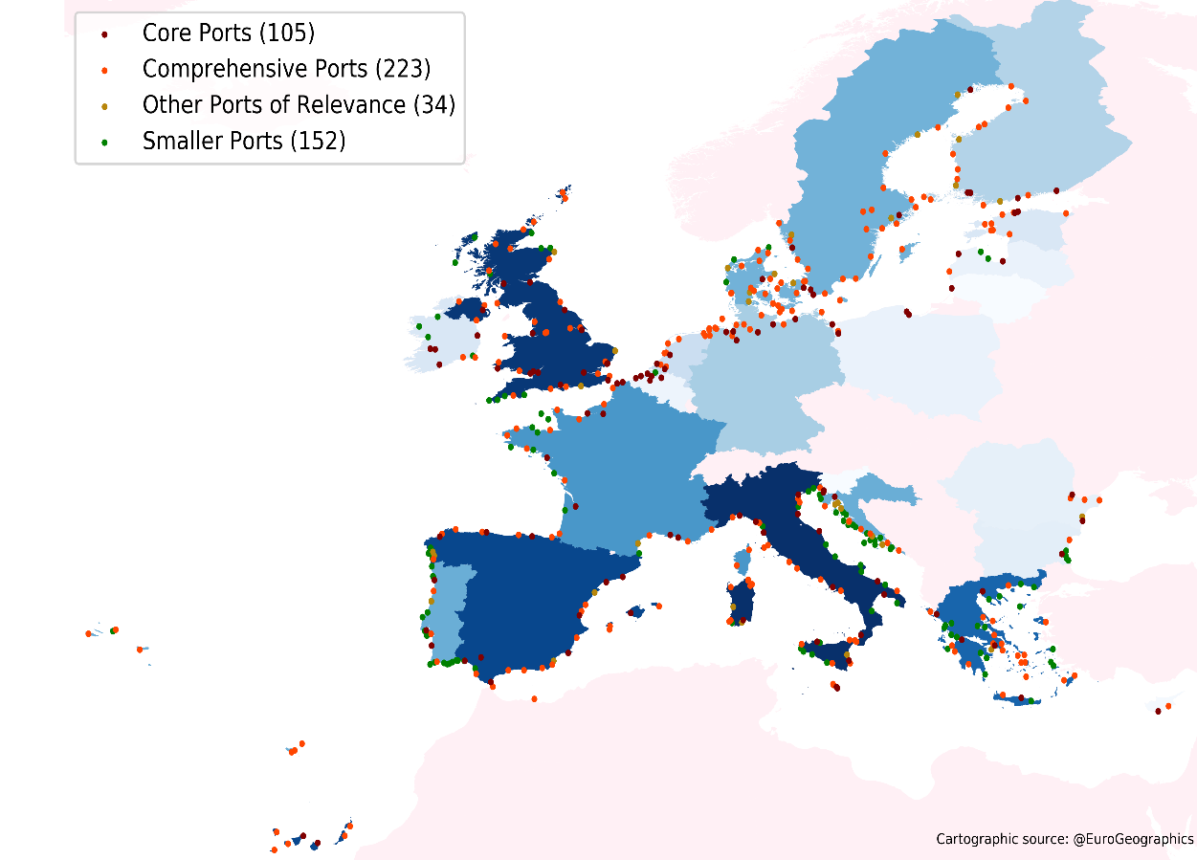
The database also includes a selection of Other Ports of Relevance (34 ports), with a GT (Gross Tonnage) higher than 1,000,000 tons per year or with a traffic higher than 1,000,000 passengers per year, following the 2017 Eurostat statistics. Despite not being in the TEN-T network, these other relevant ports have a significant yearly traffic volume and, thus, they were considered for being of interest for the identification and proposal of CE activities. For the sake of simplicity, offshore, inland and dry ports have not been included.

Number and type
of ports per country

Finally, Main Fishing Ports (390 ports, from which 152 were classified as Smaller Ports for not being core, comprehensive or other of relevance) were added to the database. They were selected when more than 100 fishing vessels were registered according to the most recent data published by the Fleet Register of the European Commission (2017 or 2016 when 2017 annual data is not available). The reason for their inclusion in the study is that, regarding projects such as RepescaPlas (Spanish National founds) or Ecoalf initiative, fishing ports are potential areas of interest for plastic and biomaterials waste collection. Moreover, the fish canning industries and their logistics facilities regarding this kind of activity are usually located close to these ports and must be certified by sanitary and phytosanitary inspection services (Border Inspection Points and Port Health Authorities). This small-scale infrastructure of enterprises can favor the establishment of circular economy activities.

Analysis of the Database: Type of traffics
A total of 45 variables were analyzed for each of the selected ports, including:
- 10 variables related to overall characteristics of the port.
- 10 variables related to their cargo and industrial sector, identifying the type of traffic handled on each port.
- 7 variables related to port statistics regarding Eurostat data.
- 4 variables related to their ownership, port government model, management body and level of digitalization.
- 8 variables related to their environmental management system, identifying their environmental certification, publication of environmental reports and belonging to environmental networks.
- 4 variables related to CE strategies.
- 2 variables with additional information.
As show in the graph below, fishing is the predominant activity, and it is relevant in most ports. Because it has been quantified by means of the number of fishing vessels registered on each port, it is referred herein as an activity rather than a traffic type.
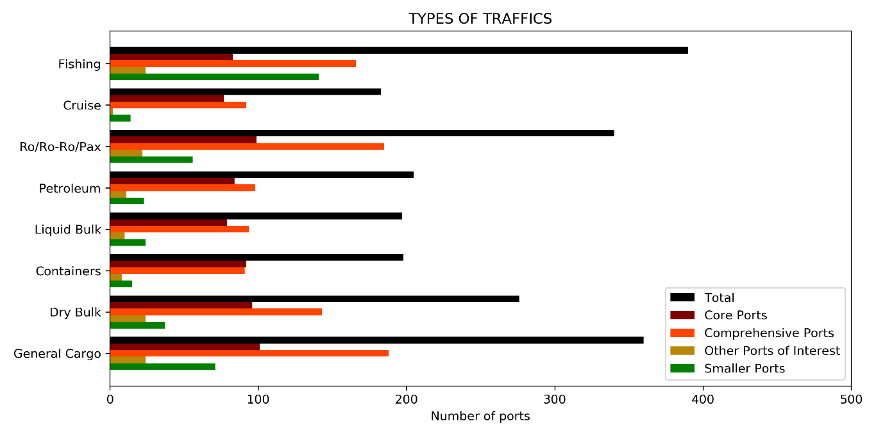

Excluding Smaller Ports, general cargo is the main traffic identified. Ro-ro/Ro-pax traffic is the second main traffic for most of the port types. This type of traffic is mostly related to ferry passengers, although there are few ports in which this traffic is dominated by the car industry. Indeed, it gathers most passenger’s traffic, as the total number of cruise passengers, the least predominant of all traffics, is just about 25% of the total number of ferry passengers. However, it has to be highlighted that the number of passengers per only one call can rise up to 6,370 for the biggest cruise ship up-to-date, the Symphony Of The Seas cruise ship. The third main traffic is dry bulk. Petroleum and liquid bulk traffic are less predominant as well as less important regarding the key material flows addressed at the LOOP-Ports Project. Finally, container traffic is one of the less predominant but, at the same time, it is one of the traffics with more future projection and it is also of relevance for the project. The number of ports with container traffic is particularly high in core ports (with respect the total number of core ports) and particularly low in comprehensive ports, other ports of relevance and, as expected, in Smaller Ports.

Analysis of the Database: Statistical Results
Regarding the statistical results (from Eurostat 2017, or 2016 when 2017 annual data was not available), it was found that the number of calls, despite including both goods and passengers traffics, is clearly dominated by the second one. This, together with the number of passengers embarked/ disembarked per year, allow the identification of main ferry routes. There are 8 ferry routes moving annually from 5 million passengers to more than 10 million passengers each. Dover-Calais and Helsinki-Tallinn are the busiest ones, followed by Messina-Reggio di Calabria, Helsinborg-Helsingör and Perama-Salamina. Finally, moving close to 5 million passengers per year each, these ferry routes are Puttgarden-Rodby, Cirkewwa-Mgarr and Algeciras-North Africa. Other ports with important passenger’s traffic are Stockholm (about 8 million), Naples (about 6 million) and Split (about 4 million). The busiest port is Piraeus in Greece, with about 14 million passengers if the traffic from Perama is also considered.
Focusing on cruise passengers, the Mediterranean Sea is the most demanded area and the countries with more passengers are Spain and Italy, being Barcelona the busiest port (about 2.7 million passengers)
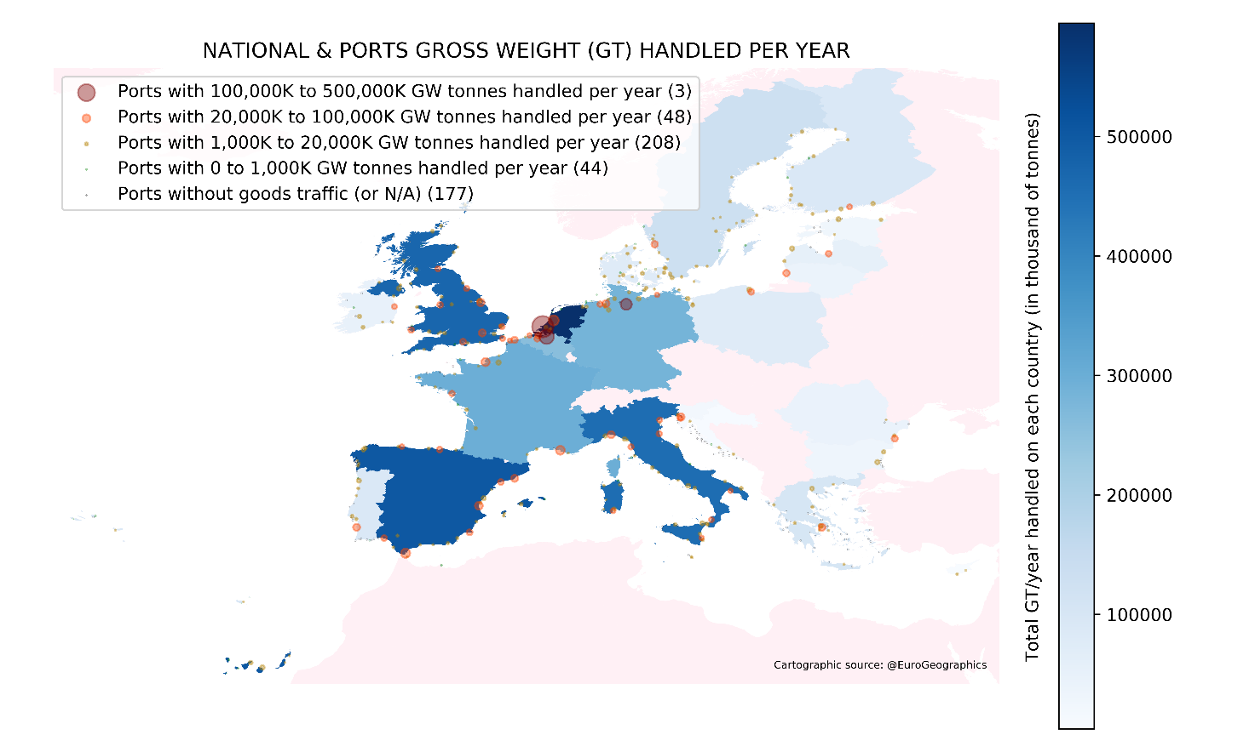

National and Port’s Gross Weight (GT) handled per year

and followed by Civitavecchia about (2.2 million passengers). Other important cruise spots with more than 1 million passengers and less than 2 million are, in decreasing order, Southampton, Palma de Mallorca, Marseille, Venice, Las Palmas and Piraeus port.
GT handled is clearly dominated by the port of Rotterdam, with about 433 million tons. This port, together with Antwerp, with about 201 million tons, and Amsterdam, with about 99 million tons, form a trident handling 20% of all the goods analyzed. In northern countries, there is another important hub in the port of Hamburg, with about 119 million tons, whereas in southern countries goods handling is less centralized, being Algeciras the port with a highest number of GT handled, with about 84 million tons.
Greece is the country with more registered fishing vessels (9,636) and, together with Portugal (7,177), they gather one third of the total number of vessels in the database. However, the highest number of registered vessels per port corresponds to Vaasa (943) and Turku (933), both located in Finland. Other important fishing ports are Fort de France (904), Aveiro (839), Limassol (805), Peniche (765) and Point á Pitre (741).

Analysis of the Database: Other results

Apart from the types of traffic and the statistical data, there are other variables that are of interest to the LOOP-Ports project.
Besides the GT handled, the total passengers per year or the number of calls, the number of terminals in a port can be also an indicator of its size and, thus, of the potential for implementing CE activities under the assumption that more chances are present in bigger ports.
28% of the analyzed ports present ongoing or planned construction or dredging activities, which are particularly relevant in Core Ports (46% of them) and also in Comprehensive Ports. These kinds of activities offer a clear possibility to implement circular actions, for example, by using dredging materials or construction debris in port’s enlargements.
Regarding metal flows, ports that combine containerized traffic together with dry docks or shipyards are particularly interesting, as they are nodes in which the containers that can no longer be used are added to the needs and metal wastes of the shipping industry. This combination is almost null in Smaller Ports and Other Ports of Relevance, but it rises up to 60% of Core Ports and 14% of
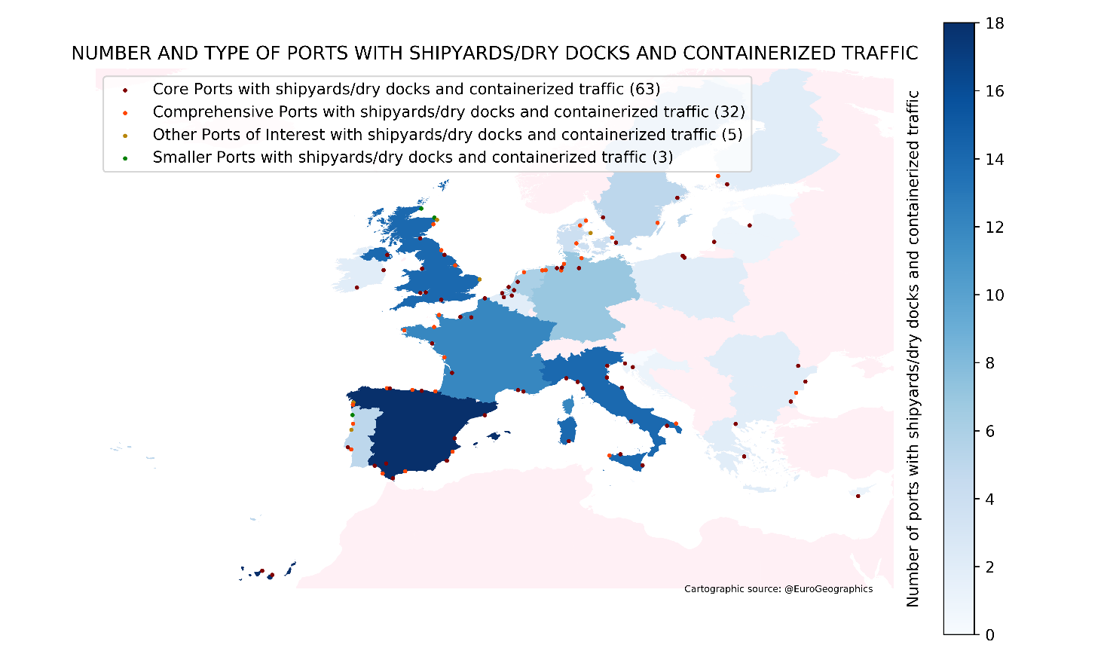
Comprehensive Ports.
Another aspect of relevance is their level of digitalization. This is in line with their own self-knowledge and their capability of monitoring, storing, and accessing to the most relevant information. In this sense, about one third of the addressed ports had a digitalization system, whether a Port Management System (PMS) or Port Community System (PCS), and they are particularly common in Core Ports and Comprehensive Ports.
Their belonging to a European or Worldwide network is also of relevance, as systemic actions might be fostered from these organizations. ESPO (European Sea Ports Organization) is possibly one of the most important, as 93% of Core Ports, 80% of Comprehensive Ports, 68% of Other Ports of Relevance and 18% of Smaller Ports are part of it. From the point of view of CE initiatives, EcoPorts or WPCI (World Ports Climate Initiative) are also networks of relevance; however, whereas 68% of the analyzed ports belong to ESPO, only 39% and 8% of the ports are so far part of EcoPorts or WPCI respectively.

Number and type of ports with shipyards/dry docks and containerized traffic

Port Sustainability Indicators

So far there is not a public port sustainability index agreed in the European Union. Little information on this sense was identified at the beginning of the project whereas, nowadays, many efforts are being made to adapt to the different sectors the global indexes proposed by the United Nations inside the 17 Sustainable Development Goals (SDG). The Eurostat settled down the following 10 indicators to monitor the progress towards circular economy:
Production and consumption
- Self-sufficiency of raw materials for production in the EU.
- Green public procurement (as an indicator for financing aspects).
- Waste generation (as an indicator for consumption aspects).
- Food waste.
Waste management
- Recycling rates (the share of waste which is recycled).
- Specific waste streams (packaging waste, biowaste, e-waste, etc.).
Secondary raw materials
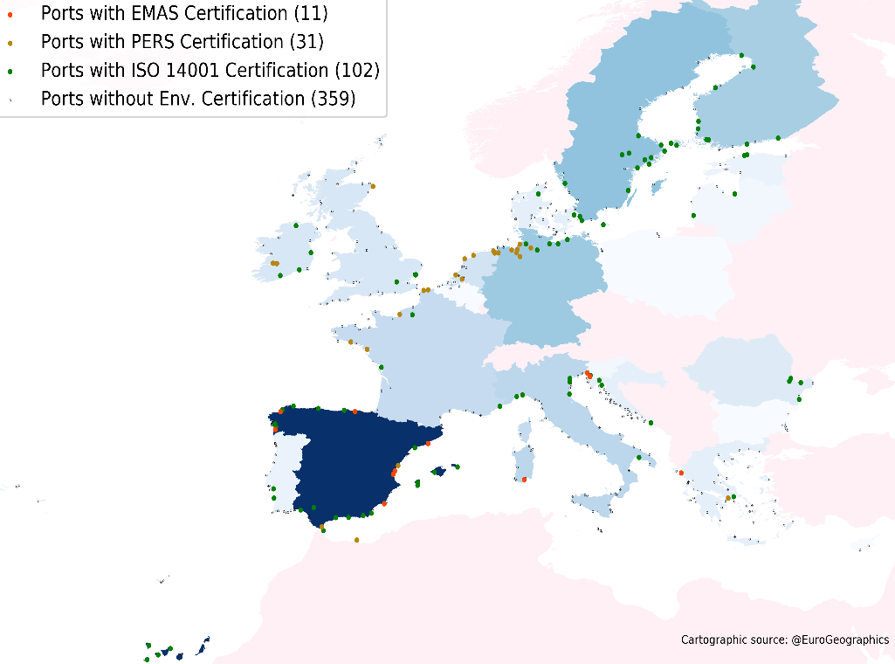
- Contribution of recycled materials to raw materials demand.
- Trade of recyclable raw materials between the EU Member States and with the rest of the world.

Number and type of ports with environmental certifications

Competitiveness and innovation
- Private investments, jobs and gross value added.
- Patents related to recycling and secondary raw materials as a proxy for innovation.
If these indicators are to be adapted to the port sector, the first challenge is the public access to the information. Frequently, waste management in ports is carried out by private companies and this information is not usually shared with open access. In addition, not every waste stream is systematically monitored in every port or not monitored at all. This is the case, for example, of leftover food from cruises that, in many cases, are pumped out of the ship in deep water or any other waste stream that is not properly separated and included inside MARPOL protocols.
Environmental certifications can be seen as an indicator of the degree of commitment of a port. 21% of the analyzed ports have an ISO 14001 certification, which is the least demanding in terms of requirements, whereas just 3% have an EMAS certification, the most demanding one.

There are 6 ports that are distinguished with all the 3 environmental certifications addressed (ISO 14001, PERS and EMAS): a Greek port (Igoumenitsa) and five Spanish ports (Barcelona, Cartagena, Sagunto, Valencia and Vigo). However, if fulfilling the requirements of an environmental certification is indeed an indicator of the degree of commitment of a port regarding sustainability, the absence of an environmental certification is not necessarily linked to a lack of commitment.
Therefore, defining an index to characterize the sustainability of a port is not an easy task, as it might depends on a high number of variables, as well as on the commitment of the whole port sector to monitor and share the required information. However, it is strongly recommended to achieve an agreement, ideally at world level, on how to define the level of circularity of a port. This would help in prioritizing investments (especially regarding public funds), in evaluating the success of the actions carried out and in providing a common base to monitor the evolution of ports towards the fulfillment of the SDG for 2030.

Port Suitability Indexes to CE initiatives developed in LOOP-Ports project

Based on the 45 variables analyzed at LOOP-Port project, 5 indexes (0 to 10) were calculated for each port in order to provide a preliminary evaluation of their suitability to implement CE initiatives. Note that these indexes consider just the information that is publicly available from sources such as Eurostat or port’s webpages and they are intended to address the four materials that were aimed initially at the project: plastics, metals, cements, and biomaterials. As it was stated before, deeper information is needed to be able to build representative parameters of circularity, such as figures about consumption of resources, waste generation or recycling rates. Just as a refence, the following ports were included in the Top10 of, at least, one of the indexes proposed:

Estonia | Tallin
Finland | Helsinki, Turku
France | Nantes St. Nazaire, Calais, Fort de France
Germany | Hamburg, Bremerhaven
Greece | Piraeus, Igoumenitsa
Italy | Messina
Netherlands | Rotterdam, Amsterdam
Portugal | Setubal, Aveiro
Slovenia | Khoper
Spain | Valencia, Vigo, Algeciras, Cartagena, Sagunto, Bilbao
Sweden | Stockholm, Gothenburg
United Kingdom | Dover/Folkestone

Conclusions

Being the first step of the LOOP-Ports project, an analysis of up to 480 European ports was carried out. This analysis was focused on 45 variables that were consulted from public sources, such as the statistical annual data from Eurostat or the information available on port’s webpages. It served as a starting point to provide a broad picture of the port sector in Europe. At the same time, port’s annual environmental and sustainability reports were stored in order to provide a basis for the identification of CE activities inside Task 1.2 of the project. As a result, a database with port’s characteristics was generated and enlarged with more than 200 CE practices. This information was uploaded inside the “Circular Economy Tools” of the project webpage (https://www.loop-ports.eu/)
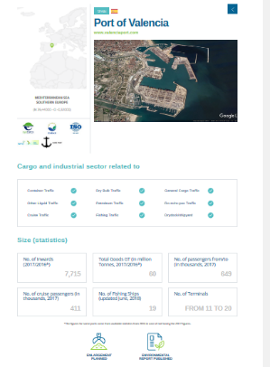

The need of a port sustainability index considering CE was identified, ideally public and agreed at world level. This would help in prioritizing investments (especially regarding public funds), in evaluating the success of the actions carried out and in providing a common base to monitor the evolution of ports towards the fulfillment of the SDG for 2030. For achieving so, main challenge nowadays is the accessibility to key information such as figures about consumption of resources, waste generation or recycling rates, as well as the systematic monitoring of all these aspects.
Due to the lack of this kind of public information, some hypothesis were applied inside LOOP-Ports project when attempting to categorize the port’s suitability to implement CE initiatives.
For example, it was assumed that bigger ports deal with a higher volume of waste streams, consume more resources and exhibit larger possibilities to find circular initiatives as they count on a higher number of actors involved, as well as equipment, facilities, business models…
Another assumption was that ports with a high level of digitalization are more likely to show a higher degree of development and self-knowledge and an increased capability of monitoring, storing, and providing access to the information.
Their belonging to a European or Worldwide network is also of relevance, as systemic actions might be fostered from these organizations.
Port efforts to fulfill the requirements for being environmentally certified (ISO 14001, PERS, and EMAS) and to publish their environmental and sustainable reports are also an indicator of their degree of commitment with sustainability.
Finally, some assumptions were also built to relate the four materials initially addressed in LOOP-Port project (plastics, cements, metals, and biomaterials) to the general classification of cargo traffics.
- Fishing activities were associated with plastics and biomaterials regarding the opportunity to recycle plastics collected by fishing nets, to deal with enhancing the durability and returnability of the nets or to valorize waste streams from the fishing and canning industry as high-value products in the nutrition and beauty industry.
- Plastics can be even linked with container traffics, as goods made of plastic from countries like China and imported by European companies must accomplish some customs formalities and there are certain containers rejected or seized to be destroyed.
- Biomaterials waste can be also related to cruise or passengers traffics, not only with respect to MARPOL V waste streams, but also considering the opportunity of cooperating with other organizations such as food banks in order to keep the value of leftovers. Passenger and cruise terminals are also nodes of interest for promoting educational awareness strategies and for implementing re-used materials in new facilities and urban furniture.
- One of the most extended circular initiative identified so far was using debris or dredged material to fill out new enlargements or preparing new roads access to the terminals under construction
- Finally, metals are normally traded as general cargo and have a potential CE interest in dry docks or shipyards activities. The presence of container traffic in the port can also foster the implementation of circular initiatives focused on metals, taking into account the containers rejected or seized to be destroyed.
As a conclusion, being strategic hubs of the logistic chain, ports are also one of the key performers in the transition towards a circular model. They combine the integration of different actors, the management of a relevant amount of goods and waste flows, and the entity to be considered as ecosystems with the opportunity to be transformed into nodes of innovation with potential to foster a systemic change.

References

European Commission:
- List of Sea Ports in the Core and Comprehensive Networks. European Commission, Brussels, 2014. Available online at: https://ec.europa.eu/transport/sites/transport/files/modes/maritime/ports/doc/2014_list_of_329_ports_june.pdf
- Fleet register on the net. European Commission, Fisheries & Maritime Affairs. Available online at: http://ec.europa.eu/fisheries/fleet/index.cfm
- Eurostat Database. European Commission. Available online at: https://ec.europa.eu/eurostat/data/database
- Circular Economy Stakeholder Platform. European Commission. Available online at: https://circulareconomy.europa.eu/platform/

Ports networks:
- ESPO Organization. Available online at: https://www.espo.be
- EcoPorts Network. Available online at: https://www.ecoports.com/
- Puertos del Estado. Ministry of Public Works (Spain). Available online at: http://www.puertos.es/es-es
- Hellenic Ports Association. ELIME. Available online at: https://www.elime.gr
- World Port Climate Initiative. IAPH (International Association of Ports and Harbors). Available online at: http://wpci.iaphworldports.org/
- World Port Sustainability Program. IAPH (International Association of Ports and Harbors). Available online at: https://sustainableworldports.org/
- International Port Community Systems Association (IPCSA). Available online at: https://www.ipcsa.international/pcs
- Flemish Port Commission. Available online at: http://www.vlaamsehavencommissie.be/vhc

Cruise’s networks:
- Medcruise. The Association of Mediterranean Cruise ports. Available online at: http://www.medcruise.com/
- Cruise Europe. Available online at: https://www.cruiseeurope.com/
- CLIA Europe. Cruise lines International Association Europe. Available online at: https://www.cliaeurope.eu/
- CLIA International. Cruise lines International Association. Available online at: https://cruising.org/
- Cruise Port Guides by Cruise Crocodile. Available online at: https://cruisecrocodile.com/
- Whatsinport cruise information. Available online at https://www.whatsinport.com
- Cruise Mapper. Available online at: https://www.cruisemapper.com
- Cruise Timetables. Available online at: https://www.cruisetimetables.com/#destports
- Cruise Compete. Available online at: https://www.cruisecompete.com/
- Greek Cruise. Available online at: http://www.greekcruise.gr/index.php/port/cruisestatistics/128
Port’s information:
- Marinetraffic. Available online at: https://www.marinetraffic.com
- Port Directory. Maritime Information Services Ltd. Available online at: https://www.port-directory.com/
- World Port Source. Available online at: http://www.worldportsource.com/ports/region.php
- Shipyards directory. Infomarine on-line. Worldwide Maritime Directory. Available online at: https://www.shipyards.gr/
- Port Economics. Available online at: https://www.porteconomics.eu/
- 4AllPorts. Available online at: www.4allports.com/
- SeaRates. Available online at: https://www.searates.com/maritime/
- PortInfo. Available online at: https://www.portinfo.co.uk/port-information/port-websites
- PortSEurope. Available online at: https://www.portseurope.com/
- Harbours Review. Available online at: http://harboursreview.com/
- Ports of the World. Available online at: http://www.odin.tc/reference/atlas.asp

Others:
- “Lloyd’s Maritime Atlas of World Ports and Shipping places” 19th edition. Published by LLP (London Press Limited) Ltd, Colchester (1997)
- Standard country or area codes for statistical use (M49). United Nations. Department of Economic and Social Affairs. Statistics Division. Available online at: https://unstats.un.org/unsd/methodology/m49/
- Juhel M., Kopicki R., Bert Kruk C., and Julian B., «Port Reform Toolkit» World Bank Transport Division, [Online]. Available online at: https://ppiaf.org/sites/ppiaf.org/files/documents/toolkits/Portoolkit/Toolkit/module3/port_functions.html.
- UNECE (United Nations Economic Commission for Europe). Available online at: https://www.unece.org/
- North Sea Port. Available online at: https://en.northseaport.com/shipping
- Hellenic Coast Guard. Available online at: http://www.hcg.gr/
- Hellenic Chamber of Shipping. Available online at: http://nee.gr/en/port-port-authorities/

Álvaro Campos Duque Rafael Molina Sánchez
Universidad Politécnica de Madrid Universidad Politécnica de Madrid
Email: alvaro.campos@upm.es Email: rafael.molina@upm.es

Jorge Miguel Lara López Rocío García Molina
Fundación Valenciaport Fundación Valenciaport
Email: jlara@fundacion.valenciaport.com Email:rgarcia@fundacion.valenciaport.com

